Electrical Distribution System Power Characteristics
Norbert Doerry
September 23, 2026
- Introduction
With the exception of uncrewed ships, shipboard electrical power systems enable ships to provide services and a suitable environment for crew and passengers, power some or all of the ship’s steering, maneuvering and propulsion systems, and power equipment necessary for the ship to accomplish its missions. In ships employing an integrated power system (IPS), the same electrical power system is used for all ship service loads (also known as “hotel loads”) as well as for propulsion motors. In mechanical drive ships, propulsion is provided by dedicated prime movers, typically medium-speed diesel engines or gas turbines. The electrical power system provides power to the ship service loads including electrically powered propulsion auxiliaries.
While shipboard power systems adhere to the same laws of physics as any other power system, their unique environment results in characteristics that differ from the usual terrestrial power system and are similar to those of islanded micro-grids. Doerry (2015) lists the following characteristics of naval power systems (power systems found on warships); these characteristics are generally consistent with those of commercial ships as well:
“• Variable frequency: The frequency cannot be assumed constant onboard ship. The limited rotational inertia of the prime movers and generators allows for rapid accelerations and decelerations of the shaft and corresponding frequency fluctuations in response to load changes. Frequency fluctuations can be expected to last up to 2 s.
• Lack of time scale separation: For naval power systems, the principal time constants of controls, machine dynamics, and electric dynamics all fall within the same general range of milliseconds to seconds. The practice of decomposing the problem by time scale separation often used in analyzing commercial power systems becomes much more difficult.
• Load sharing instead of power scheduling: The commercial power utilities operate by scheduling the power delivered by each of the generating units. The mismatch between scheduled power generation and the actual load is met by equipment acting as a swing generator. Onboard ship however, both real and reactive power are shared equally among all paralleled generators through the very fast exchange of load sharing information. This fast exchange of information strongly couples the dynamics of all the paralleled generators.
• Short electrical distances: The distances onboard ship are so short (typically under 350 m) as to make the modeling of transmission lines unnecessary for many applications and to trivialize the load flow problem which is so important to the commercial power sector. The short electrical distances also strengthen the dynamic coupling of the various subsystems making up the electrical power system.
• Load dynamics: Commercial utilities usually assume loads are either consuming constant real and reactive power, or are constant impedances. Shipboard systems however, must account for dynamics of loads such as propulsion motors, large pumps, pulsed loads, propeller dynamics, and ship dynamics.
• Tighter control: Because a ship is relatively small, a higher level of centralized control can be exercised over the shipboard power system than can be exercised in the commercial power industry.
• Ungrounded or high-impedance grounded systems: Naval power systems are designed to enable continued operation with a single line to ground fault.
• Physical Environment: Shipboard power system equipment must be able to operate in a pitching, and rolling ship. Vibration, humidity, salinity, and shock must all be accounted for in the design.”
A shipboard power system can usually be decomposed into a number of interconnected “busses.” Each bus is usually, but not always, a separately derived system with respect to the other busses. In a separately derived system, a ground fault on one bus does change the relationship of the neutral voltage to ground of any other bus. As described in IEEE Std. 45.1, shipboard busses can generally be classified into one of the following types:
- Primary bus
- Distribution bus
- Secondary bus
- Special bus
Power quality refers primarily to the characteristics of the voltage waveforms at the interface between loads and the power system that the power system is designed to achieve assuming loads adhere to requirements for characteristics of the current waveforms at the interface.
Quality of Service (QOS) is a metric of the reliability of the power system in providing power of the requisite quality from the perspective of the load. QOS is a useful concept for ensuring loads are provided with sufficiently reliable power at minimum cost.
- Bus Types
  - Primary bus
As defined by IEEE Std. 45.1:
“A primary bus is a term reserved for an ac or dc bus with a nominal system voltage greater than 1000 V and applies only to vessels with a primary bus. A primary bus may be implemented as multiple buses for redundancy, criticality, or safety. A primary bus usually is only directly connected to a few large loads; the majority of the loads are powered from other buses that connect to the primary bus via power conversion equipment (e.g., transformers, solid-state power converters).”
Often, ships with a primary bus employ an integrated power system with electric propulsion or hybrid-electric propulsion. If a medium voltage shore power connection is anticipated, then either 6.6 kV or 11 kV ac power at 60 Hz. should be employed to simplify conformance with IEC/ISO/IEEE 80005-1. Otherwise, standard ac nominal system voltages are defined as: 3.3 kV, 4.16 kV, 6.6 kV, 11 kV, and 13.8 kV. Standard dc nominal system voltages are defined as 1.5 kV, 3 kV, 6 kV, 12 kV, 18 kV, 24 kV, and 30 kV.
The U.S. Navy has defined standard ac nominal system voltages of 4.16 kV, 6.6 kV and 13.8 kV at 60 Hz in MIL-STD-1399-300-2.
  - Distribution bus
As defined by IEEE Std. 45.1:
“A distribution bus provides power to loads throughout a ship or a zone. Multiple distribution buses may be utilized as necessary for the vessel design. Distribution buses typically support nominal system voltages between 400 V and 1000 V.”
Standard ac nominal system voltages are defined as: 400 V, 450 V, 480 V, 600 V, and 690 V. Standard dc nominal system voltages are defined as 600 V, 650 V, 700 V, 750 V, and 1000 V. The U.S. Navy has also defined its standard nominal user voltage to be 440 V in MIL-STD-1399-300-1 and its standard dc nominal system voltage to be 850 V in MIL-STD-1399-300-3.
  - Secondary bus
As defined by IEEE Std. 45.1:
“A secondary bus provides electrical power with a nominal system voltage typically no greater than 400 V directly to equipment, appliances, or appliance outlets.”
Standard ac nominal system voltages are defined as: 120 V, 208 V, 230 V, 240 V, and 400 V. Standard dc nominal system voltages are defined as 110 V, 220 V, and 375 V.
The U.S. Navy has defined its standard nominal user voltages to be 115 V and 200 V in MIL-STD-1399-300-1.
  - Special bus
As defined by IEEE Std. 45.1:
“A special bus provides power for unique purposes such as medical use, control system power, special control, or propulsion.”
- Power Quality Requirements
  - IEEE Std. 45.1
Table I depicts power quality requirements defined in IEEE Std. 45.1 for ac power. IEEE Std. 45.1 also provides the following definitions:
“frequency tolerance: The maximum permitted departure from nominal frequency of the fundamental waveform during normal operation, excluding transients. It includes variations caused by load changes, environment (temperature, humidity, vibration, inclination), switchboard meter error, and drift. Tolerances are expressed in percentage of nominal frequency.
frequency transient: A sudden change in frequency (f_{system}) of the fundamental waveform from an initial frequency of operation (f_{initial}) that goes outside the frequency tolerance limits, returns to, and remains inside these limits within the frequency transient recovery time after initiation of the disturbance. Frequency transient tolerance is in addition to frequency tolerance limits and measured as percentage of nominal frequency.
Frequency transient tolerance (%) = $\left[\frac{f_{system}-f_{initial}}{f_{nominal}}\right]×100$
frequency transient recovery time: The time period from the start of the disturbance until the frequency recovers and remains within frequency tolerance limits.
frequency modulation: The permitted recurring variation in frequency during normal operation over a period up to 10 s. Frequency modulation may be caused by regularly and randomly repeated loading. Frequency modulation is measured as a percentage of nominal frequency.
Frequency modulation (%) = $\left[\frac{f_{max}-f_{min}}{2 × f_{nominal}}\right]×100$
voltage tolerance: The maximum permitted departure of the system voltage from nominal system voltage during normal operation, excluding transient variations. It includes variations such as those caused by load changes, environment (temperature, humidity, vibration, inclination), switchboard meter error, and drift. The voltage tolerance is measured as a percentage of nominal system voltage.
voltage transient: A sudden change (excluding spikes) in system voltage that goes outside the user voltage tolerance limits and returns to and remains within these limits within the time period between 1 ms and the voltage transient recovery time after the initiation of the disturbance. The voltage transient (percent) is the difference between the instantaneous system voltage (V_{transient}) during the disturbance and the instantaneous value of the fundamental voltage waveform (V_{system}) extrapolated from immediately prior to the disturbance, expressed as a percentage of nominal system voltage.
Voltage transient (%) = $\left[\frac{V_{transient}-V_{system}}{V_{nominal}}\right]×100$
voltage transient recovery time: The time elapsed from initiation of the disturbance until the system voltage recovers and remains within voltage tolerance limits.
line voltage unbalance (three-phase system): The difference between the highest and lowest line-to-line voltages (rms) measured as a percentage of nominal system voltage.
Line voltage unbalance (%) = $\left[\frac{V_{line_to_line_max}-V_{line_to_line_min}}{V_{nominal}}\right]×100$”
Table I: IEEE Std. 45.1 Alternating current (ac) power characteristics)
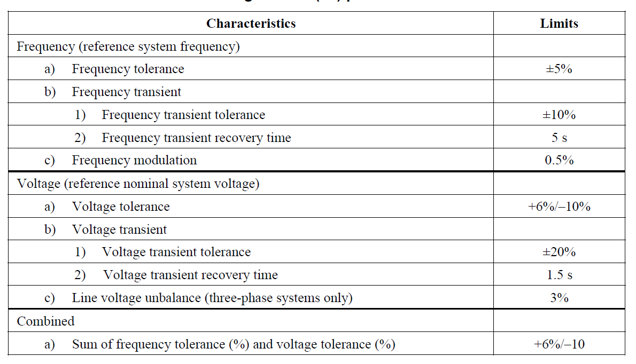
IEEE Std. 45.1 also provides the following guidance …
“The total waveform distortion (TWD) of the voltage at the switchboard, load center, or power panel directly connected to a load should not exceed 8% and any single frequency component of the voltage waveform should not exceed 5%. If these values are exceeded, distribution equipment and load equipment should be designed to operate at the higher values. The impacts of higher voltage waveform distortion (above the levels specified previously) such as increased heat losses, instrumentation errors, and possible system instability should be evaluated to ensure system performance is not degraded. If economical, consideration should be given to limiting the TWD of the voltage waveform to no more than 5% and limiting any single frequency component to no more than 3%. If the TWD of the voltage waveform exceeds 5% or any single frequency component exceeds 3%, equipment specifications should include the expected maximum values for TWD and the equipment vendors should be made aware of this requirement.
Load equipment should limit current distortion in accordance with IEEE Std 519 under all operating conditions from standby to full load. For the purpose of applying IEEE Std 519, the point of common coupling should be considered the load connection to a switchboard, load center, or power panel. In cases where the current waveform distortion is above that specified in IEEE Std 519, the impacts of the higher current waveform distortion such as increased heat losses, instrumentation errors, and possible system instability should be evaluated, and current waveform distortion mitigation means should be incorporated as they are needed to help ensure adequate system performance. IEEE Std 519 provides guidance for mitigation means.”
And the following definition …
“total waveform distortion (TWD): The ratio in percentage of the rms value of the residue (after elimination of the fundamental) to the rms value of the fundamental.”
Table II depicts power quality requirements defined in IEEE Std. 45.1 for dc power below 1000 volts. IEEE Std. 45.1 also provides the following definitions:
“Voltage limits are expressed as a percentage of the nominal system voltage value. Steady-state voltage tolerance, steady-state voltage range and steady-state voltage ripple are in root mean square (rms). Steady-state peak-to-peak voltage deviation and voltage transient tolerance are instantaneous values.
Steady-state voltage ripple is the rms value of the non-dc periodic component of the voltage.
Steady-state peak-to-peak voltage deviation is the magnitude of the difference between the maximum and the minimum instantaneous voltage in steady-state conditions. It includes both periodic and random deviations, often referred to as PARD.”
Table II: IEEE Std. 45.1 Direct current (dc) power characteristics)
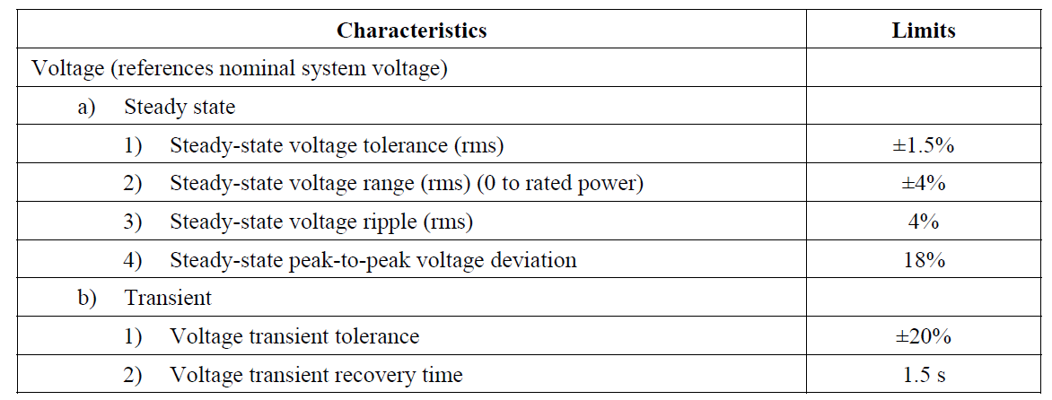
  - IEEE Std. 1709
Figure 1 depicts medium voltage dc (1 kV and above) voltage tolerances as specified in IEEE Std. 1709.
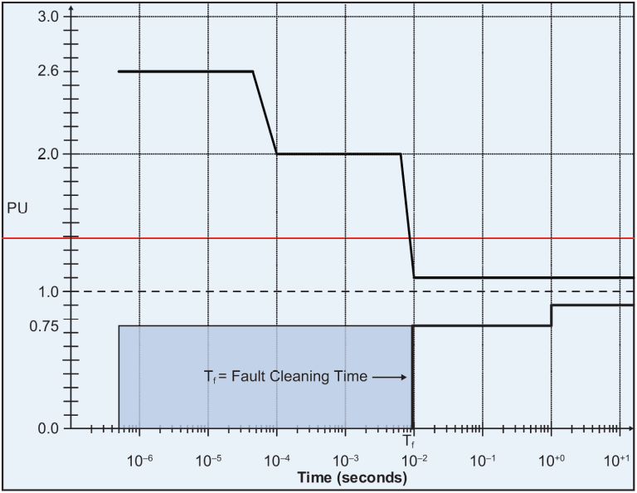
Figure 1: IEEE Std. 1709 MVDC voltage tolerances worst case envelope
IEEE Std. 1709 also provides the guidance on ripple:
“The acceptable rms value of ripple voltage and load induced noise should not exceed 5% per unit.”
  - MIL-STD-1399-300-1
Table III depicts power quality requirements defined in MIL-STD-1399-300-1 for low voltage ac power. Definitions are generally consistent with IEEE Std. 45.1; MIL-STD-1399-300-1 provides the following additional definitions:
“3.4.3 Frequency tolerance. Frequency tolerance is the allowed variation from nominal frequency expressed as a percent of the nominal frequency; the permitted tolerance is provided in (Table III), Item 3. This tolerance is the maximum permitted value during normal operation including variations caused by small load changes, environmental effects (temperature, humidity, vibration, and inclination), and drift, excluding modulation and transients. The frequency tolerance may be calculated using (the following equation).
Frequency tolerance (percent) = $\left[\frac{f_{measured}-f_{nominal}}{f_{nominal}}\right]×100$
Where:
f_{measured} is the measured frequency and f_{nominal} is the nominal frequency
3.4.4.1 Frequency transient tolerance. Frequency transient tolerance is the allowed variation from nominal frequency expressed as a percent of the nominal frequency during transient conditions; ....
Frequency transient tolerance (percent) = $\left[\frac{f_{transient}-f_{nominal}}{f_{nominal}}\right]×100$
Where:
f_{transient} is the measured frequency transient and f_{nominal} is the nominal frequency
3.5.2 Voltage unbalance (line-to-line). (See IEEE Std. 45.1 line voltage unbalance)
3.5.7.1 Voltage transient tolerance. Voltage transient tolerance is the allowed variation from nominal voltage expressed as a percent of the nominal voltage during transient conditions.
Voltage transient tolerance (percent) = $\left[\frac{V_{transient}-V_{nominal}}{V_{nominal}}\right]×100$
3.5.10.3 Voltage total harmonic distortion (THD). The THD of a voltage wave is the ratio in percentage of the rms value of the residue (after elimination of the fundamental) to the rms value of the fundamental
Voltage THD (percent) = $100 ×\sqrt{\sum_{h≥2}{{\left(\frac{V_{h}}{V_{fundamental}}\right)}^{2}}}$
Where:
V_{h} is the rms voltage of individual harmonics
3.5.10.4 Voltage deviation factor. The voltage deviation factor of the voltage waveform is the ratio (a/b) where “a” is the maximum deviation between corresponding ordinates of the waveform and of the equivalent sine wave and “b” is the maximum ordinate of the equivalent sine wave when the waveforms are superimposed in such a way that they make the maximum difference as small as possible. … The equivalent sine wave is defined as having the same frequency and the same rms voltage as the waveform being tested.
Voltage deviation factor (percent) = $\left[\frac{Maximum Deviation}{Maximum ordinate of the equivalent sine wave}\right]×100$”
MIL-STD-1399-300-1 has specific requirements for the current waveforms that loads should follow. The most common requirements are …
“5.2.6 Current (load) unbalance. User equipment that is three-phase or comprised of a combination of single-phase and three-phase loads shall have a resulting input three-phase line current unbalance not exceeding 5 percent (submarines 3 percent) using normal operating current under normal operating conditions during normal operating modes. This current shall be measured at nominal voltage in all operating modes with a voltage source having a line voltage unbalance less than 1 percent. Three-phase current unbalance shall be calculated as defined in 3.6.1. This requirement does not apply to aircraft servicing systems that are designed for a maximum current unbalance of 15 percent of the user equipment rating.
5.2.7 User equipment pf. User equipment shall operate within the user frequency and voltage tolerance envelope of figures 10 through 16 as applicable with a pf within the range of 0.8 lagging to 0.95 leading for 60 Hz and 0.8 lagging to 0.9 leading for 400 Hz under normal steady state operating conditions, excluding start-ups and pulsing loads. There is no pf requirement for loads operating less than 1 kVA.”
Additional requirements are provided for ramp loads and pulsed loads. The magnitudes of non-fundamental frequency components of the current waveform are also limited.
Table III: MIL-STD-1399-300-1 Low voltage ac power system characteristics
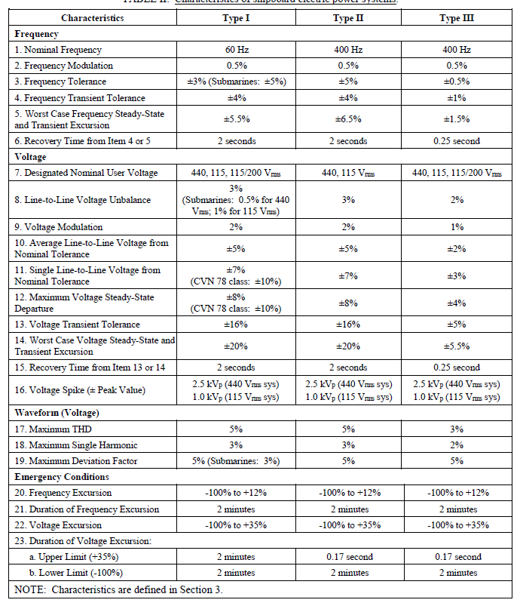
  - MIL-STD-1399-300-2
Table IV depicts power quality requirements defined in MIL-STD-1399-300-2 for medium voltage ac power. Definitions are consistent with MIL-STD-1399-300-1.
Table IV: MIL-STD-1399-300-2 Medium voltage ac power system characteristics
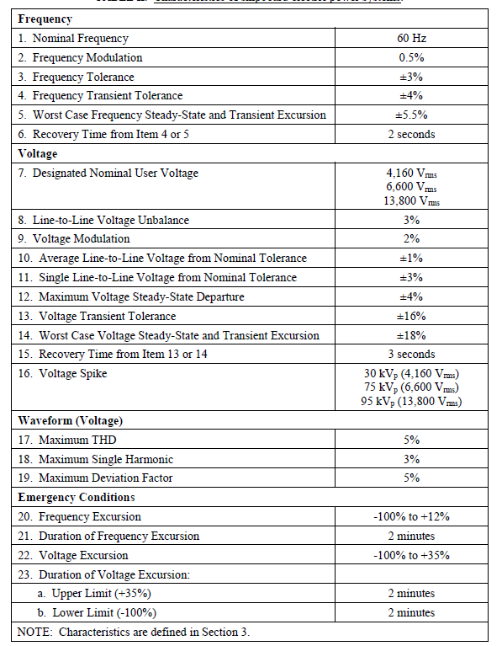
  - MIL-STD-1399-300-3
Table V and Table VI depict power quality requirements defined in MIL-STD-1399-300-3 for low voltage dc power. Definitions are generally consistent with MIL-STD-1399-300-1; MIL-STD-1399-300-3 provides the following additional definitions:
“3.31.2 User equipment normal service steady-state voltage range. The range of steady-state DC voltage that, when applied to user equipment (including voltage ripple), the user equipment is expected to function normally. This range accounts for possible voltage drop in the distribution system as well as the power source normal service voltage range. For type II power, this is characterized as user equipment normal service voltage range, overcharged to discharged. This is the degree to which voltage can vary solely due to varying states of charge of the energy storage system.
3.31.5 User equipment voltage transient tolerance. The allowed variation from nominal voltage expressed as a percent of the nominal voltage during transient conditions.
3.31.6 Voltage transients. A sudden change in voltage (longer than 1 millisecond) that exceeds the normal service steady-state voltage range, positively or negatively and returns to and remains within these limits within a specified recovery time.
3.31.1 User equipment maximum steady-state voltage ripple (peak-to-peak percent of nominal system voltage). The maximum peak-to-peak value of the non-DC component of the voltage measured at the input of a user equipment.”
Additional requirements are provided for ramp loads and pulsed loads. The magnitudes of ripple frequency components of the current waveform are also limited.
Table V: MIL-STD-1399-300-3 Low voltage dc power system characteristics: Type I and Type III power
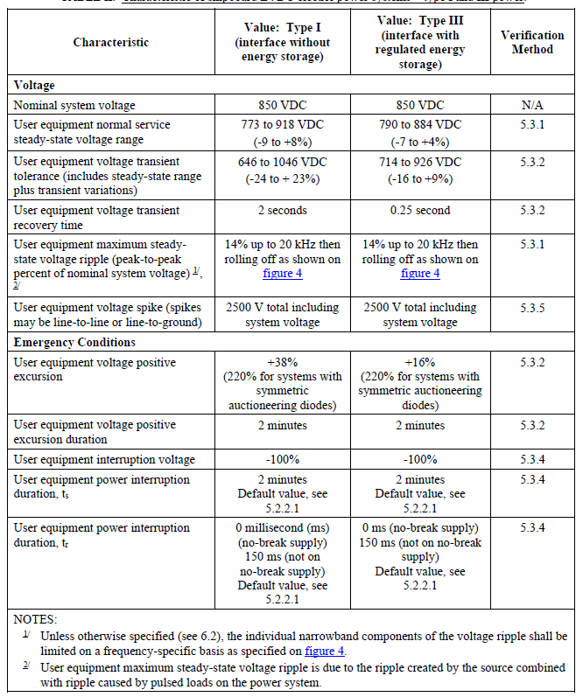
Table VI: MIL-STD-1399-300-3 Low voltage dc power system characteristics: Type II power
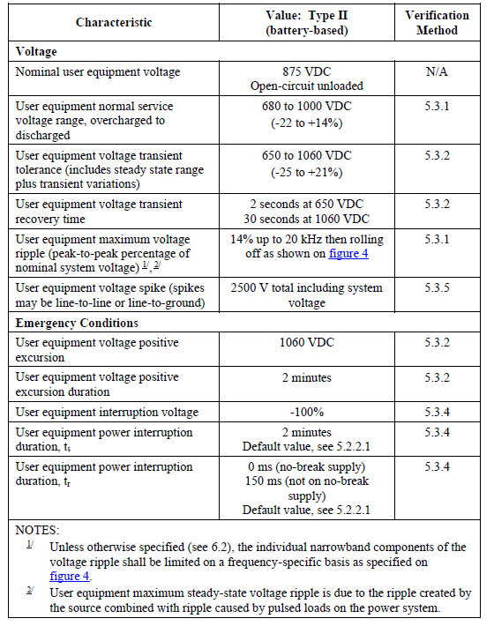
  - ABS MVR
Table VII depicts power quality requirements from the American Bureau of Shipping (ABS) Marine Vessel Rules (MVR). The MVR does not provide definitions for the terms.
Table VII: ABS MVR power system characteristics: Type II power
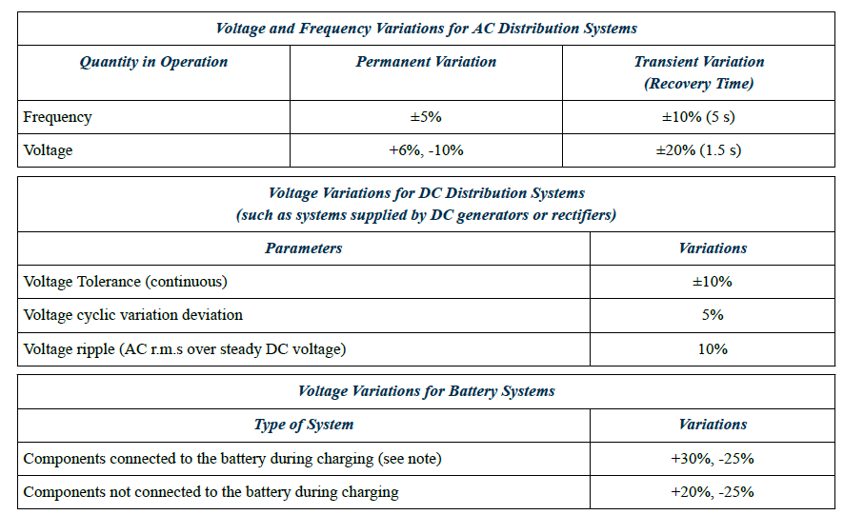
- Quality of Service
  - Introduction
Quality of Service (QOS) is a reliability metric for the shipboard electrical power system as experienced by individual loads. QOS is defined in IEEE Std 45.1 and IEEE Std 45.3.
One key QOS metric is “Mean Time Between Service-Interruption” or MTBSI. A service interruption is defined in terms of the length of time that power quality is outside of prescribed standards (or power is lost altogether) as compared to the amount of time a load can tolerate the power quality being outside of prescribed standards; a service interruption only occurs if the power quality is outside of prescribed standards for a longer period of time than the load can tolerate.
The customer establishes the requirement for MTBSI for each load. A customer may elect to not apply QOS to non-critical (non-vital) loads; essentially treating all non-critical loads as exempt loads. For other loads, a MTBSI requirement of 30,000 hours is not unreasonable.
  - QOS terms
To prevent service interruptions, categorizing loads with respect to two system metrics, t1 and t2 is useful. As defined in IEEE Std 45.1:
“Reconfiguration time (t1) is defined as the maximum time to reconfigure the distribution system without bringing on additional generation capacity.”
“Generator start time (t2) is defined as the maximum time to bring the slowest power generation module online.”
If a load would experience a service interruption with power outside of power quality requirements of duration t1, it is classified as an uninterruptible load.
If a load would not experience a service interruption with power outside of power quality requirements of duration t1, but would with duration t2, it is classified as a short-term interrupt load.
If a load would not experience a service interruption with power outside of power quality requirements of duration t2, it is classified as a long-term interrupt load. A subset of long-term interrupt load is classified as “Exempt Load” if restoring power to these loads is not required upon loss of a generator set.
Technology choices in the design of the power system impact the values of t1 and t2. The values of t1 and t2 in turn impact how loads are categorized and how the power system should be designed to minimize service interruptions.
For example, if conventional electro-mechanical circuit breakers are used in a system, then t1 can be on the order of seconds. If solid state circuit breakers are used, then t1 can be on the order of milliseconds. Many loads that would be classified as uninterruptible loads with electro-mechanical circuit breakers would be classified as short term interrupt loads with the solid-state circuit breakers. Uninterruptible loads typically require distributed uninterruptible power supplies (UPS) to avoid service interruptions. With the use of solid-state circuit breakers, these distributed UPSs may not be required at all, or replaced with more economical centralized UPSs.
- References
ABS Marine Vessel Rules
MIL-STD-1399-300-1 Low Voltage Electric Power, Alternating Current
MIL-STD-1399-300-2 Medium Voltage Electric Power, Alternating Current
MIL-STD-1399-300-3 Low Voltage Electric Power, Direct Current
IEEE Std. 45.1 IEEE Recommended Practice for Electrical Installations on Shipboard—Design
IEEE Std. 519 IEEE Standard for Harmonic Control in Electric Power Systems
IEEE Std. 1709 IEEE Recommended Practice for 1 kV to 35 kV Medium-Voltage DC Power Systems on Ships
Doerry, Norbert, "Naval Power Systems," IEEE Electrification, Volume 3 Number 2, June 2015, pp. 12-21.

